Biodiesel Processor

Mega Ester 40 Gallon

Standard Operating Procedure

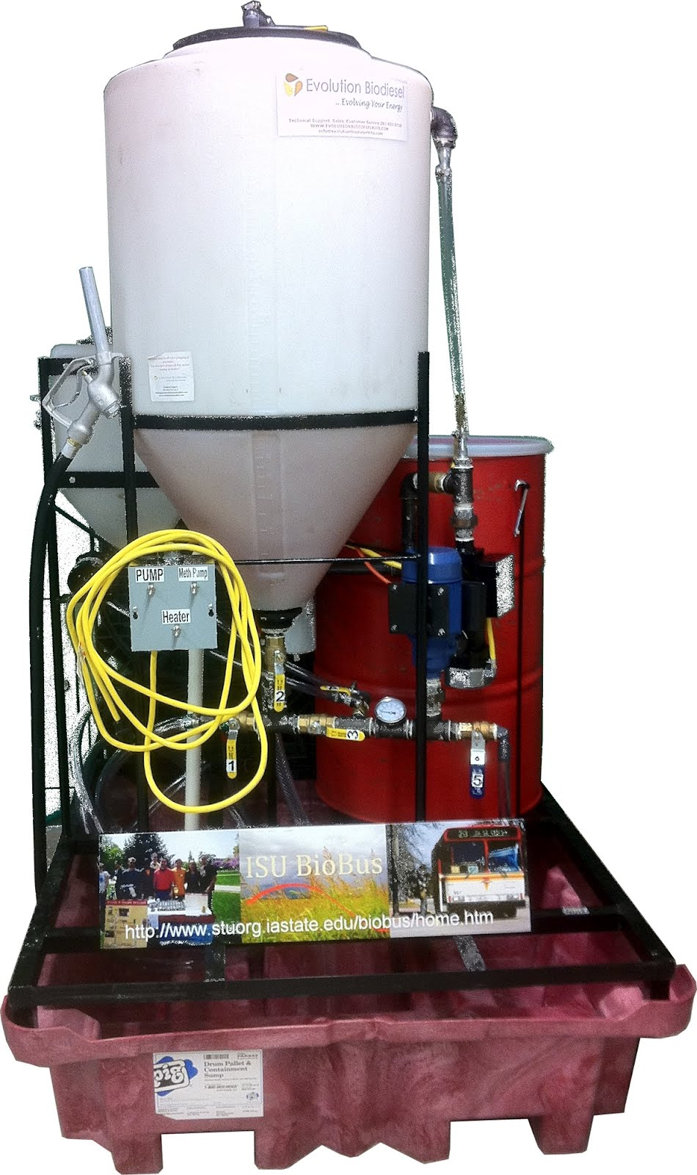

Biodiesel Processor
Mega Ester 40 Gallon

Standard Operating Procedure

Center of Sustainable & Environmental Technologies – ISU
Location: 1115 BRL

 | Name(s) | Date
Written by: | Eric Burke  Jenny Kuplic  Nathan Powelson  Jordan Gheer-Bertrand | 3 May 2012
Revised by: | Bernardo del Campo | 3 May 2012
Reviewed by:
Approved by:

Contacts:
Responsible Student/Post Doc: | Bernardo del Campo  (515) 441-2116  bernidc@iastate.edu
Lab Supervisor: | Ryan Smith  (515) 203-1640  rgsmith@iastate.edu
Group Leader: | Dr. Robert C. Brown  (515) 294-7934  rcbrown@iastate.edu
EH&S: | (515) 294-5359
Contents
Safety Considerations 4
Required Personal Protective Equipment (PPE) 4
Biodiesel Processing Regulations 5
Potential Hazards 5
Chemical 5
Electrical 5
High temperatures 5
Miscellaneous 6
Miscellaneous 6
Brief Description of Equipment 7
Biodiesel Processor Reference Chart 8
Processor Timeline 11
Operation Instructions 11
Connect Super Sucker to the Biodiesel Processing Unit 11
Transfer Oil into the Processor 12
Drying the Oil 12
Perform the Titration 12
Prepare Reactants 13
Transferring and Mixing Reactants to Oil Tank 13
Draining the Glycerol 13
Washing the Biodiesel 13
Drying the Biodiesel 14
Transferring Biodiesel into Fuel Can 14
Titration 14
Sodium Hydroxide (NaOH) Calculation 14
Methoxide Calculation 15
Shut down and clean up 16
Emergency shut down 16
Waste disposal 16
Measurement System conversion 16

Safety Considerations
The following rules and guidelines are in place to prevent accident and injury. This summary of points is not exhaustive but an overview of the most important points.
- No eating or drinking in the lab
- Safety course requirements:
  - Lab Safety Fundamental
  - Management of Unwanted Materials for Laboratory Personnel
  - Fire Safety and Extinguisher Training

- Personal protective equipment (PPE) must be worn all the times while in the lab.
  - See Required Personal Protective Equipment
- For storing/transporting liquid (biodiesel or glycerin), always fill containers no more than 90% full, never fill to the top.
- Properly label every container, chemical or waste product according to EH&S regulations (label placed on the satellite area)
- In case of spill refer to the SPILL SOP

Required Personal Protective Equipment (PPE)
The following PPE is required to operate this equipment:
- Safety Glasses: must be worn all time in the laboratory.
- Lab Coats: must be worn all time in the laboratory.
- Gloves: must be worn when working with the processor (making biodiesel), chemicals, or cleaning to avoid skin contact.
- Hand/Arm Protection: Skin contact hazards can come from particulate, high temperatures, or chemicals in this lab (read MSDS for the chemical being used). When working with chemicals wear appropriate chemically resistant nitrile gloves. Hot surfaces require heat resistant gloves (leather gloves).
- Foot Protection: Closed toed shoes are required at all times while in the lab (e.g. no sandals or flip-flops). Steel-toed footwear is recommended for doing heavy lifting.
Refer to the Laboratory Safety Manual for additional detailed information on PPE and other related hazards.

Biodiesel Processing Regulations
- Operators must read the entire Standard of Operation and be approved by a supervisor before starting any activity with the reactor.
- Authorized users must be listed with the supervisor.
- A minimum of two people must be present in the lab to operate the reactor.

Further information regarding regulations can be found by contacting the supervisor, manufacturer or the emergency contacts.

Potential Hazards
The following list details the hazards associated with running this equipment.

Chemical
Poisonous gases: Methanol is used as a reactant during processing. It can be harmful if inhaled or ingested in large enough amounts and/or concentrations. Refer to the MSDS forms for more information related to proper handling and safety procedures.

Reactive: The catalyst used (sodium hydroxide) is very reactive with skin, metals, wood and other materials. Be very careful when handling this. Special attention should be taken over the countertops, as they will be stained forever.

Electrical
Ensure the leads on the heater are kept within the electrical panel. The system should be unplugged whenever electrical work is done. Clean up any spills and cover any exposed wires when the reactor is de-energized.

High temperatures
Hot Surfaces and Environment: While the processor does not run at extremely high temperatures, care should be taken when handling heated biodiesel to prevent burns. Do not touch, until sufficiently cool as determined using an infrared thermometer.

Miscellaneous
Lab Hygiene: A messy and disorganized laboratory space is a potential hazard, not to mention an unsightly impression. Keep the floor and counters clean.
MSDS: attached to the document is detailed information for every chemical.

Miscellaneous
Registering data
All information should be registered in both the laboratory notebook and the computer. Refer to the Good Laboratory Practice (GLP) guidelines for proper documentation on the notebooks.

Valve Operation
The valves on all the equipment operate in the same manner. When the valve handle is oriented perpendicular to the pipe, the valve is in the closed position, when parallel to the pipe, is in the Open position.

Valve Closed | Valve Open
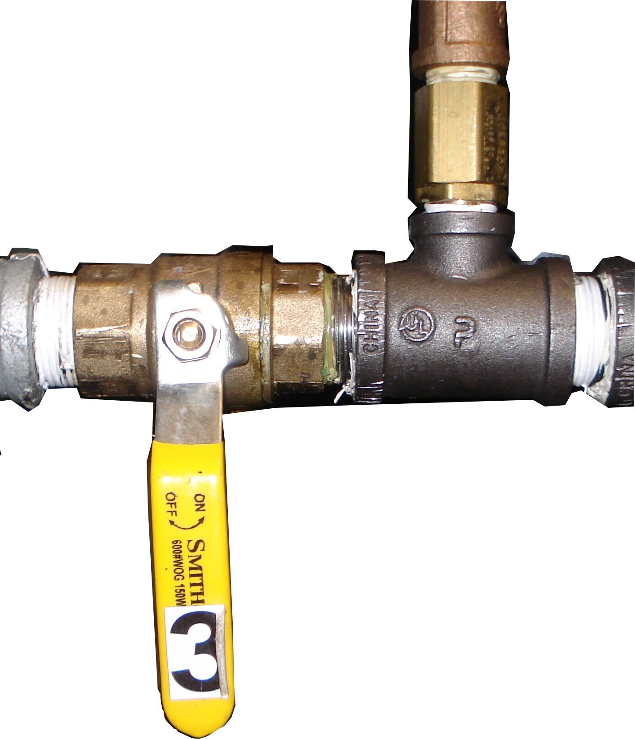 | 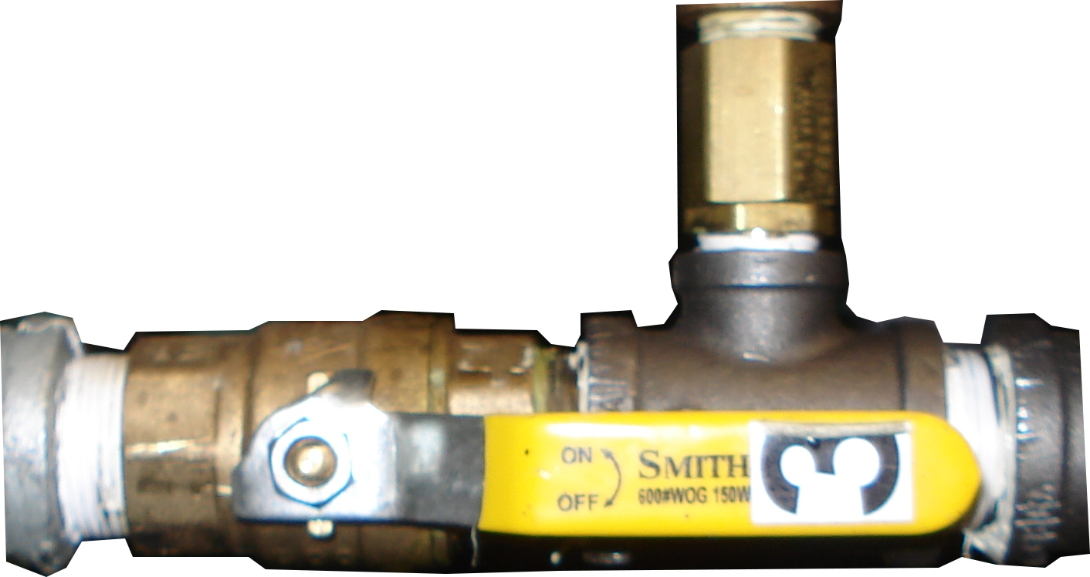
Figure 1

Brief Description of Equipment
The biodiesel processor (see Figure 2) converts waste vegetable oil (WVO) into biodiesel using methanol and the catalyst sodium hydroxide (NaOH) or potassium hydroxide (KOH). The processor consists of a 15 gallon meth oxide mixing system and a 55 gallon plastic conical-bottom processing tank. Other parts include a chemical pump, heater, and control panel with thermostat and switches. The unit’s capacity is 40 gallons of biodiesel per batch.
Figure 2

This page was intentionally left blank.

Biodiesel Processor Reference Chart
The following reference charts indicate the relative locations of operable parts of the processor.

Table 1
Part # | Description
1 | Processor Lid
2 | Circulation Tube
3 | Valve 6
4 | WVO Storage Drum (Don’t use)
5 | Pump
6 | Super Sucker hose connection
7 | Valve 5
8 | Temperature Gauge
9 | Valve 4
10 | Valve 3
11 | Valve 7
12 | Valve 1
13 | Valve 2
14 | Control Panel: Pump and Heater Switches
15 | Titration Tank
16 | Diesel Nozzle
17 | Processor Tank
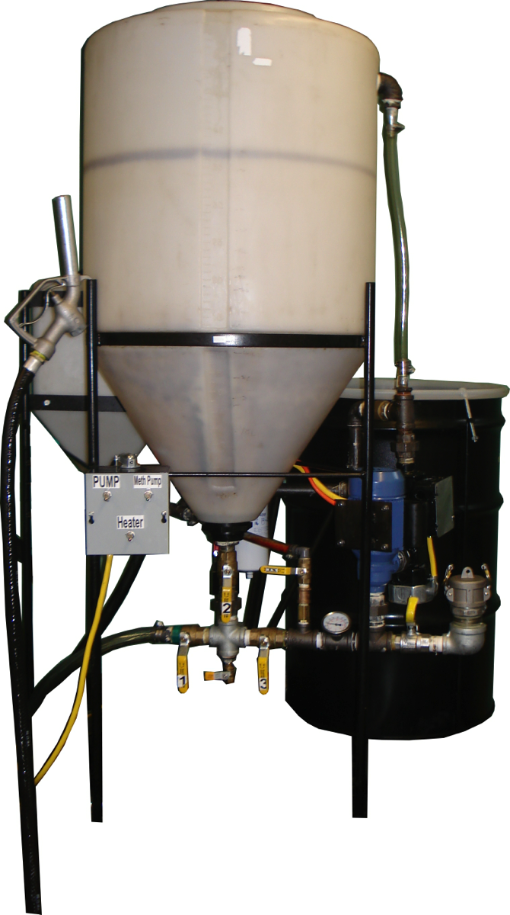
Figure 3
16
17
15
14
13
12
11
10
9
8
7
6
5
4
3
2
1

2
7
3
4
5
6
17
8
11
16
15
9
14
10
12
13

Processor Timeline
The following table outlines the operation steps and the associated expected duration. If any step takes significantly longer than as noted below, stop processing and notify contacts as listed at the beginning of this SOP.

Table 2
Task | Duration
Transfer Oil into the Processor | 10 | min
Drying the Oil | 2 | hr
Sampling & Titration | 20 | min
Preparing Reactants | 1 | hr
Transferring and Mixing Reactants with Oil | 2 | hr
Draining the Glycerol | 10 | min
Washing the Biodiesel | 1 | hr
Drying the Biodiesel | 3 | hr
Transferring Biodiesel into Fuel Can | 10 | min

Operation Instructions

Connect Super Sucker to the Biodiesel Processing Unit
- Move super sucker in front of the Biodiesel Processing Unit.
- Make sure the circulatory pump, methanol pump, and heater switches are turned off.
- Ensure all valves on the processor are closed. Ensure Valves A, B, D, E of super sucker hose are closed.
- Remove the end cap from the super sucker hose by lifting the side levers.
- On the biodiesel processing unit, remove the cap on the hose attachment port in the same way. Lift levers and remove cap.
- Connect the super sucker hose to the biodiesel processor at the attachment port by inserting the hose and locking hose levers.
  - Make sure connection is secure.

Transfer Oil into the Processor
- On the super sucker, open valve B.
- On the processor, open valve 5.
- Connect air compression line to the super sucker.
  - The metal end to the pump and the open end to the fitting above valve D.
- Open valve D.
- Open valve F and make sure E is closed.
- Air is sucked in through valve F into super sucker tank.
- Turn on air compressor on the super sucker by switching it on. This puts pressure in tank causing oil to flow into processor.
    - To speed up process, turn the processor’s circulatory pump.
- Fill processor tank to 40 gallons max.
- Turn off the pump.
- NOTE: IF there is more than 40 gallons of oil on the super sucker.
  - Attach air compression line to connection on valve A.
  - Open valve and purge the hose and processor pipeline.
- Close Valve 5.
- Turn compressor off.
- Close valve B.
- Open levers to detach hose from processor attachment.
    - Detach slowly to avoid spills.
- Replace super sucker cap on hose and lock side levers.
- Cap the processor’s attachment port and lock side levers.
- Detach air compression line from outlet by valve D.
- Leave valve D open to release pressure in super sucker tank.
- Put super sucker away to the left of the Biodiesel Processing Unit.

Drying the Oil
- Ensure all valves on the processor are closed.
- Open valve 2, and valve 3.
- Turn pump on.
- Wait 30 seconds, Turn on heater.
  - Heater must be turned on after pump! Otherwise you might burn the heater!
- Take lid off the processor’s tank to speed up drying process.
- Let the oil circulate for 2 hours until dry.
  - Determine dryness when oil becomes clear.

Perform the Titration
- Remove 10mL of oil from the processor tank through valve 7.
- Refer to the Titration section to obtain amount of methanol and catalyst needed.

Prepare Reactants
- Add calculated amount of methanol into the methanol mixing tank.
- Turn methanol pump on.
- Divide calculated amount of catalyst (potassium or sodium hydroxide) into 4 units.
- Add one unit of catalyst to the methanol mixing tank.
- Once dissolved, add the next unit of catalyst. Repeat until all catalyst is dissolved.
  - NOTE: Adding catalyst is exothermic, thus it needs to be done slowly.
- Once catalyst is dissolved, turn off methanol pump.
- Ensure oil temperature is at 60 degrees Celsius.
  - NOTE: if oil temperature exceeds 65ºC, shut off pumps and heater.

Transferring and Mixing Reactants to Oil Tank
- Replace processing tank lid.
- Transfer contents slowly from methanol tank to oil by slightly opening valve 4, enough to allow flow methanol tank to empty for no less than 10 minutes.
- When transfer complete close valve 4.
- Wait 2 hours.
- Turn heater off.
- Turn pump off.
- Let the contents of the processor tank settle overnight.
- Make sure all valves on processing unit are closed.

Draining the Glycerol
- The glycerol will be on the bottom and biodiesel on top.
- Drain the glycerol into a bucket by opening valve 1 and 2 until you notice a change from glycerin to biodiesel.
- Close valve 1.
- Place glycerol waste into 50 gallon waste drum.

Washing the Biodiesel
- Take water hose from the wall and attach to nozzle on the processor tank lid.
- Place lid on tank.
- Turn on water supply to allow a light midst.
- Once approximately 5 gallons of water settles at the bottom of the tank, slightly open valve 1 and release water into the floor drain.
  - Continue simultaneously adding and draining water at an equal rate until approximately 40 gallons of water has been drained.
- Turn off water supply.
- Remove hose from the lid on the top of the reactor.
- Wrap hose up and put it away.
- Let tank contents settle for about 15 minutes, until water and oil separate.
- Drain water into the drain by opening valve 1.
- Close valve 1 when Biodiesel begins to drain.

Drying the Biodiesel
- Take off the processor tank lid.
- Open valve 2 and 3.
- Turn on the pump.
- Turn on the heater.
- Let circulate and dry for 2 to 4 hours.
  - The biodiesel is dry once it has become clear.
- Turn off the heater.
- Turn off the pump.
- Close all valves.

Transferring Biodiesel into Fuel Can
- Obtain a biodiesel fuel can and write the date of collection on it.
- Take the fuel nozzle that is attached to the reactor and insert into fuel can.
- Open valve 6.
- Pump the biodiesel into the can by turning the circulatory pump on.
- Be attentive to the biodiesel level in the fuel can.
- When biodiesel level of fuel can reaches 90% full, turn pump off.
- Close valve 6.
- Cap the fuel can.
- Put the Biodiesel fuel can in the containment cabinet.

Titration

Sodium Hydroxide (NaOH) Calculation
Determine the amount of sodium hydroxide (NaOH) or potassium hydroxide (KOH) you will need for the trans-esterification reaction.
Needed Chemicals:
      - 1ml Waste Vegetable Oil (WVO)
      - 10 mil Isopropyl alcohol
      - 3 drops Phenolphthalein
      - Potassium Hydroxide or Sodium Hydroxide solution ($1 g/L$ at 99% purity)

Steps:
- Mix 1 ml of WVO, 10 ml isopropyl, 3 drops of phenolphthalein in a beaker.
- Slowly add sodium hydroxide solution to other three ingredients stirring often until the solution turns pink-magenta for 10 or more seconds.
- Once this color change occurs, record the amount of NaOH added.
- Now calculate the needed amount of sodium hydroxide:
  - Take the amount of NaOH solution from above and calculate how many grams you added add 5 to that number and assign units of g/L
    - example: for 2ml of NaOH added, $2+5=7$ g/L
  - If you are using potassium hydroxide, use a conversion factor e.g. 85% KOH= x1.65, 90% KOH= x1.56 and 92% KOH = x1.52 to multiply (2 + 5).
  - This number will be the total amount of NaOH you will need to convert to 1 L of the titrated oil.
- Multiply the gallons of oil in the tank by 3.78 liters. That number is how many liters you have.
  - Example: 40 gal * 3.78 L/gal = 151.2 L
- Now multiply the total Liters of oil (151.2 L) by NaOH conversion (7 g/L) to get the total amount of sodium hydroxide you need.
  - Example: 151.2 * 7 g/L = 1058.4 total g NaOH.

Methanol Required
Calculate amount of methanol needed for reaction:
- Multiply gallons of oil in the tank by 20%. This number is how many gallons of methanol you will need for a reaction.
  - Example: $40 gal of oil*0.20 \frac{gal MeOH}{gal oil}=8 gal MeOH$

Shut down and clean up
Wash beakers, counters, and floor.

Emergency shut down
If something goes wrong, turn off all the switches and turn all valves to the off position. In the contacts section, contact the “Responsible Student” or “Lab Supervisor” immediate to report and resolve the problem.

Waste disposal
- Place glycerin disposal in the 55 gallon drum waste container.
- Only fill all containers no more than 90% full.
- Place containers in satellite area.
- Fill the online request for picking up the waste when containers are filled close to 90% capacity or when the waste is close to expiration (60 days after starting the waste accumulation).

Measurement System conversion
Volume conversion
1GAL = 3.78 LTS

Mass conversion
1LB = .454 KG =454 GR

